   Firefly String Lights

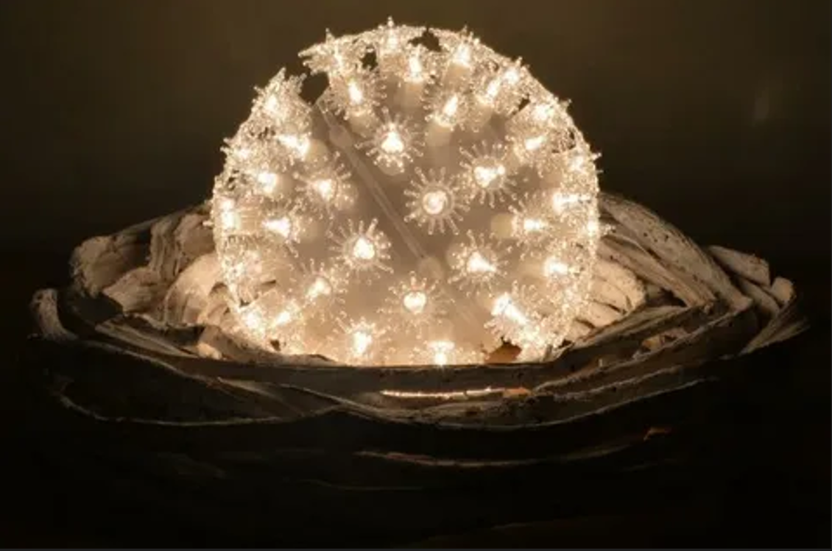

#### ****Description:****

**Firefly String Lights** are enchanting, energy-efficient lighting solutions designed to mimic the natural glow of fireflies. These lights are perfect for creating a magical and whimsical ambiance in both indoor and outdoor settings. With their delicate design and warm glow, Firefly String Lights are ideal for weddings, parties, gardens, and home decor.

* **Technology:** LED.
* **Power Source:** Battery-operated or plug-in (depending on the model).
* **Bulb Type:** Mini LED bulbs.
* **Wattage:** 2W (battery-operated), 5W (plug-in).
* **Lumens:** 20 lumens per bulb.
* **Color Options:** Warm white, cool white, multicolor.
* **Dimmable:** No.
* **Lifespan:** 20,000 hours.
* **Energy Efficiency:** Energy-efficient LED technology.
* **Weather Resistance:** IP44 rated (splash-proof for outdoor use).

#### ****Key Features:****

* **Firefly Effect:** Mimics the natural glow of fireflies for a magical ambiance.
* **Energy-Efficient:** Uses LED technology for long-lasting and energy-saving performance.
* **Versatile Use:** Suitable for indoor and outdoor settings, including weddings, parties, and home decor.
* **Battery or Plug-In Options:** Choose between battery-operated or plug-in models for convenience.
* **Weather-Resistant:** Splash-proof design for outdoor use.
* **Flexible and Durable:** Flexible wire allows for easy shaping and wrapping around objects.

#### ****Pricing:****

* **20-Foot Battery-Operated Firefly Lights:** $19.99
* **20-Foot Plug-In Firefly Lights:** $24.99
* **50-Foot Battery-Operated Firefly Lights:** $39.99
* **50-Foot Plug-In Firefly Lights:** $49.99

#### ****Where to Use:****

* **Weddings:** Create a romantic ambiance for ceremonies and receptions.
* **Parties:** Add a festive touch to indoor and outdoor celebrations.
* **Gardens:** Illuminate trees, bushes, and outdoor decor.
* **Home Decor:** Enhance bedrooms, living rooms, and patios with a cozy glow.
* **Retail Displays:** Highlight products with a magical and inviting atmosphere.

### ****Customer Reviews:****

* ⭐⭐⭐⭐⭐ "These Firefly String Lights are absolutely magical! They add such a cozy and whimsical touch to my garden and living room." – Sarah L.
* ⭐⭐⭐⭐ "Great value for the price. The lights are bright, and the battery-operated option is super convenient for outdoor use." – James T.
* ⭐⭐⭐⭐⭐ "I love how energy-efficient these lights are. The warm white glow is perfect for creating a relaxing atmosphere." – Emily R.

### ****How to Order:****

1. Visit our website: [www.brightworldlighting.com](http://www.brightworldlighting.com/)
2. Select your preferred length and power source (Battery-Operated or Plug-In).
3. Add to cart and proceed to checkout.
4. Enjoy free shipping on all orders over $50!

### ****Warranty and Support:****

* **Warranty:** 1-year limited warranty covering manufacturing defects.
* **Customer Support:** Contact us at [support@brightworldlighting.com](mailto:support@brightworldlighting.com) or call +1-800-123-4567 for assistance.

### ****Visual Representation:****

Include high-quality images of the Firefly String Lights in different settings (e.g., weddings, gardens) to showcase their versatility and design.